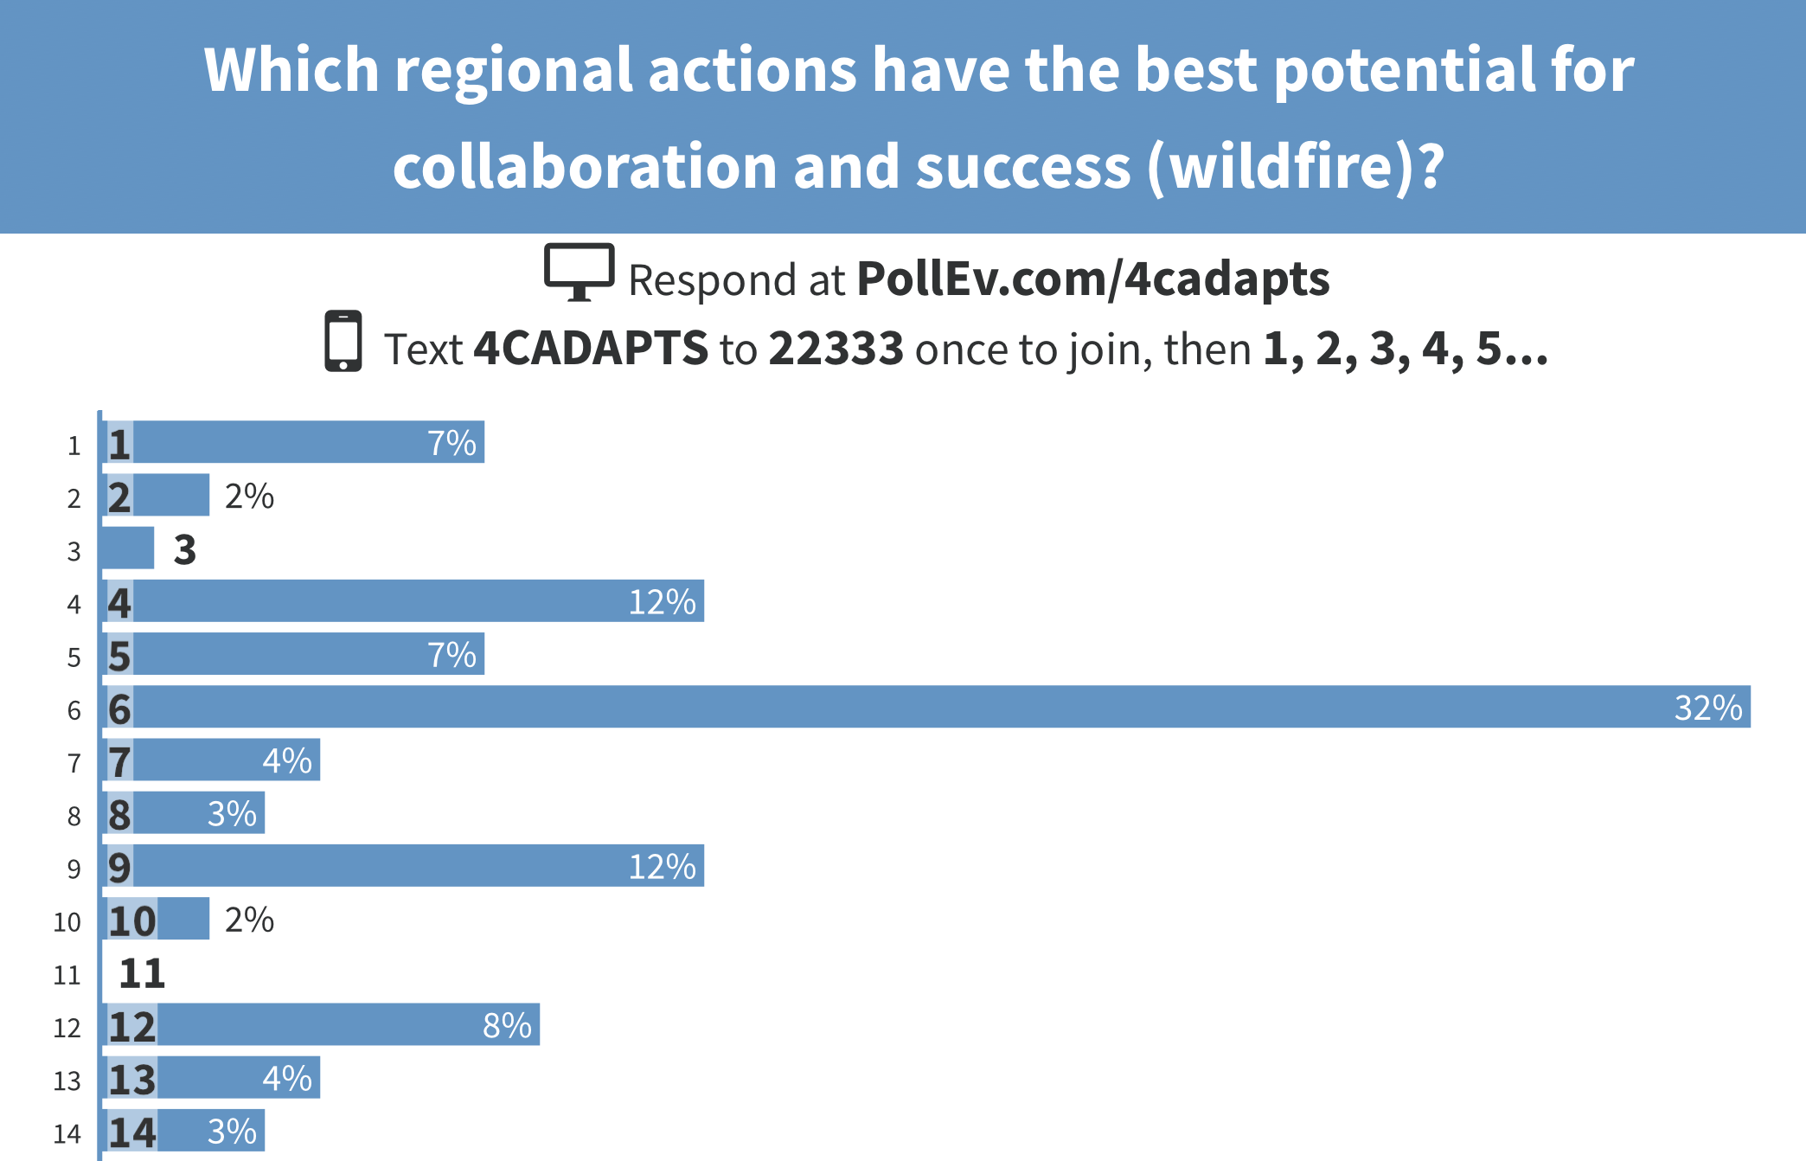

Wildfire: Voting List
- Contact lifeline and critical Services assessment
- Asses water / energy connection
- Jobs housing balance vulnerability seasonal Workforce
- Multi hazard assessment
- Regional fire response assessment. Water / Supply etc.
- Regional no build easement downsizing in critical fire areas
- Bonds for fire mitigation projects
- Work with agricultural communities to improve resilience
- Electrical upgrades
- Upgrades to housing
- Upgrades to fire response infrastructure
- Regional evacuation Strategies
- Regional collaboration knowledge sharing and resources
- Share fuel reduction strategies

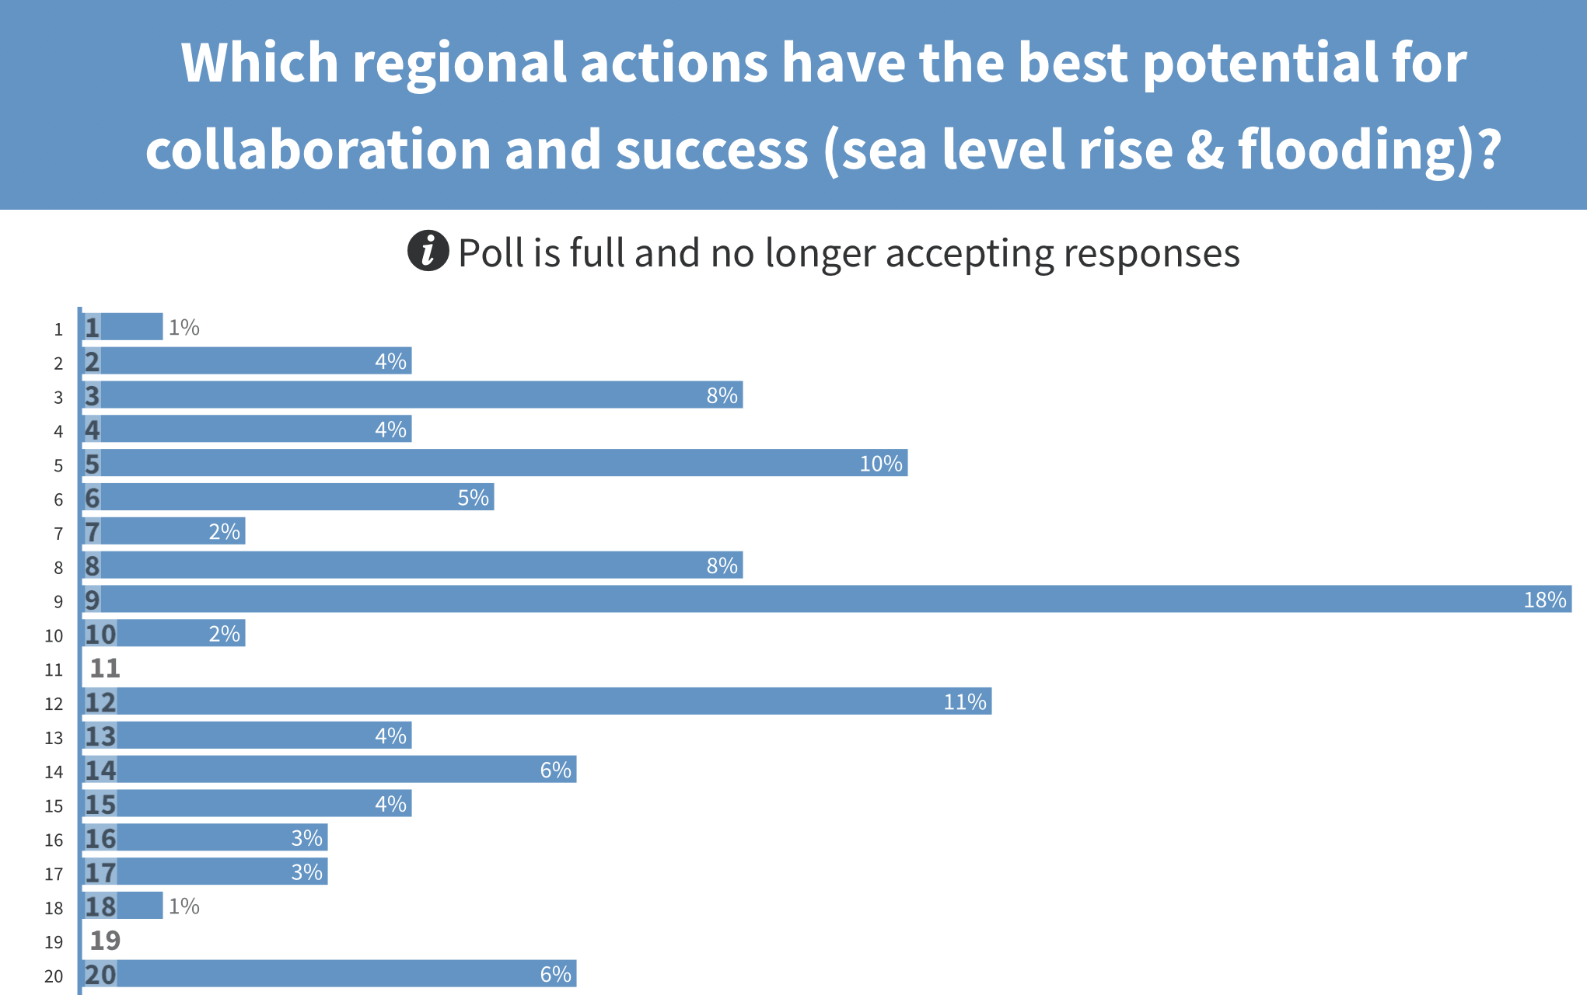
Sea Level Rise: Voting List
- Study Transportation Network: identified alternate transit routes
- Assess Critical Services
- Study dynamics of coastal armoring (impacts & feasibility)
- Costs to tourism business etc.
- Intentional EJ
- Identify and maintain areas for access/ tourism
- Utilized tourism money to fund
- Educate within the communities
- 50-year retreat plan
- Backup power for power plant
- Saltwater injection
- Restore sand dunes
- Acquire upland areas
- Notify property owners of risks
- Build adaptive capacity for zoning and permits
- Update sediment plan
- Retrofit utility lines and all utilities
- Alternative transportation network along coast road
- Prioritize opportunity to move main road inland
- Relocate critical infrastructure inland

